**Exploring the Role of Carbon Markets**

**in Supporting China’s Carbon Neutrality Goal**

**Contents**

**Introduction** 1

**China’s Climate Ambition and the Pathway to “30-60 Goals”** 1

**The Role of Carbon Markets in Achieving Carbon Neutrality** 3

Current state of China’s carbon markets 3

The role of emission reduction credits (ERCs) 4

ETS has the potential to support power sector transition 5

CCERs: the missing piece in the carbon markets 5

China’s engagement in global voluntary carbon markets 7

Carbon removals are necessary to achieve net zero 7

**Major Challenges and Uncertainties** 8

Future design of the national ETS 8

CCER scheme and regulation 8

Carbon price 9

Policy overlaps and interaction with other national mitigation strategies 9

Participation in the global carbon markets 11

**Recommendations for Future Development of China’s Carbon Markets** 12

# **Introduction**

According to the Intergovernmental Panel on Climate Change (IPCC)[1], staying within the 1.5°C limit will require immediate and deep emission reductions and for that global net anthropogenic CO2 emissions need to decrease by half by 2030 relative to 2010 levels and become “net zero” by 2050 — a state where any remaining emissions are balanced by CO2 removals from the atmosphere. There is an urgent need to explore innovative approaches to facilitate transformational change towards a net-zero economy, and carbon pricing can be a powerful and efficient tool in a broader policy toolkit to incentivize sectoral transformations and align investments to decarbonize the global economy.

As the world’s largest carbon emitter, China announced to achieve carbon neutrality by 2060 in response to tackling climate change. Carbon markets has been identified as a key component among a set of policy instruments to lowering the cost of reducing carbon emissions, driving technology innovation, and contributing to the achievement of China’s carbon peak and carbon neutrality goals. Building on its successful experience of piloting emissions trading system (ETS) in seven regions, China launched a national ETS in 2021 for the power sector covering 40% of its total carbon emissions. As a complement to the compliance market, China launched the China GHG Voluntary Emission Reduction Program (or China Certified Emission Reduction – CCER) in 2012 but have halted issuing credits since 2017 due to low trading volume and regulation issues. However, CCER is expected to restart in 2023 and play a significant role in achieving decarbonization targets and reducing costs in both domestic and global markets. CCER has been adopted as eligible credits by CORSIA, and can be potentially traded within China’s Belt and Road (B&R) regime and other international carbon markets. Additionally, China has been a major host country selling credits in the international voluntary carbon markets through projects developed under the developed to the Verified Carbon Standard (VCS) and Gold Standard. Despite these strategies and progress made, there is still a lack of details on how China would achieve the ambitious neutrality target and what actions and policy support would be required to ensure a net-zero transition pathway. [Add a few sentences on carbon crediting mechanism – CCER and engagement in VCM]

The Climate Finance and Economics unit of the Climate Change Group (SCCFE) plans to compile a series of case studies to assess the role of carbon markets in supporting countries’ net zero strategies and to promote knowledge sharing at the global level. China was selected as the first case study given the fact that it is the world’s largest carbon emitter and hosts the world’s largest carbon market by emissions. This summary report was developed based on preliminary results from a research study conducted by the Tsinghua University, that documented the best practices from China and explored the role of carbon markets in contributing to China’s long term decarbonization goals – the 2060 carbon neutrality target. The analysis covers two key components:

* ETS [add definition]: an ETS places a quantitative limit (a cap) on the amount of GHG emissions. Regulated entities are required to surrender one allowance for each unit of emissions for which they are responsible.
* Carbon crediting mechanism [add definition, noting both domestic and international are covered]: Crediting mechanism issue emissions reduction units (credits) to eligible project activities to recognize quantified emissions reductions that are real, additional, permanent, and below a baseline scenario. Crediting mechanisms can be classified into three categories based on how credits are generated and the way the crediting mechanism is administered. In the case of China, both domestic and international crediting markets are discussed in the analysis.

It is envisioned that the initial findings from internal note will help lay the groundwork as the World Bank’s Partnership for Market Implementation (PMI) program finalizing the Implementation Support Plan before kicking off the engagement with China for supporting the development of national ETS, voluntary carbon markets (the CCER), and other carbon pricing instruments in the coming years. This case study on China is also intended to inform our broader strategy on carbon markets and net zero as we develop country-tested tools and technical support for client countries. [Add sentence to indicate that this work is also intended to inform our broader strategy on carbon markets and net zero]

[Add diagram adjusting the one below]

**Figure 1. Summary of Differences Between Carbon Pricing Instruments**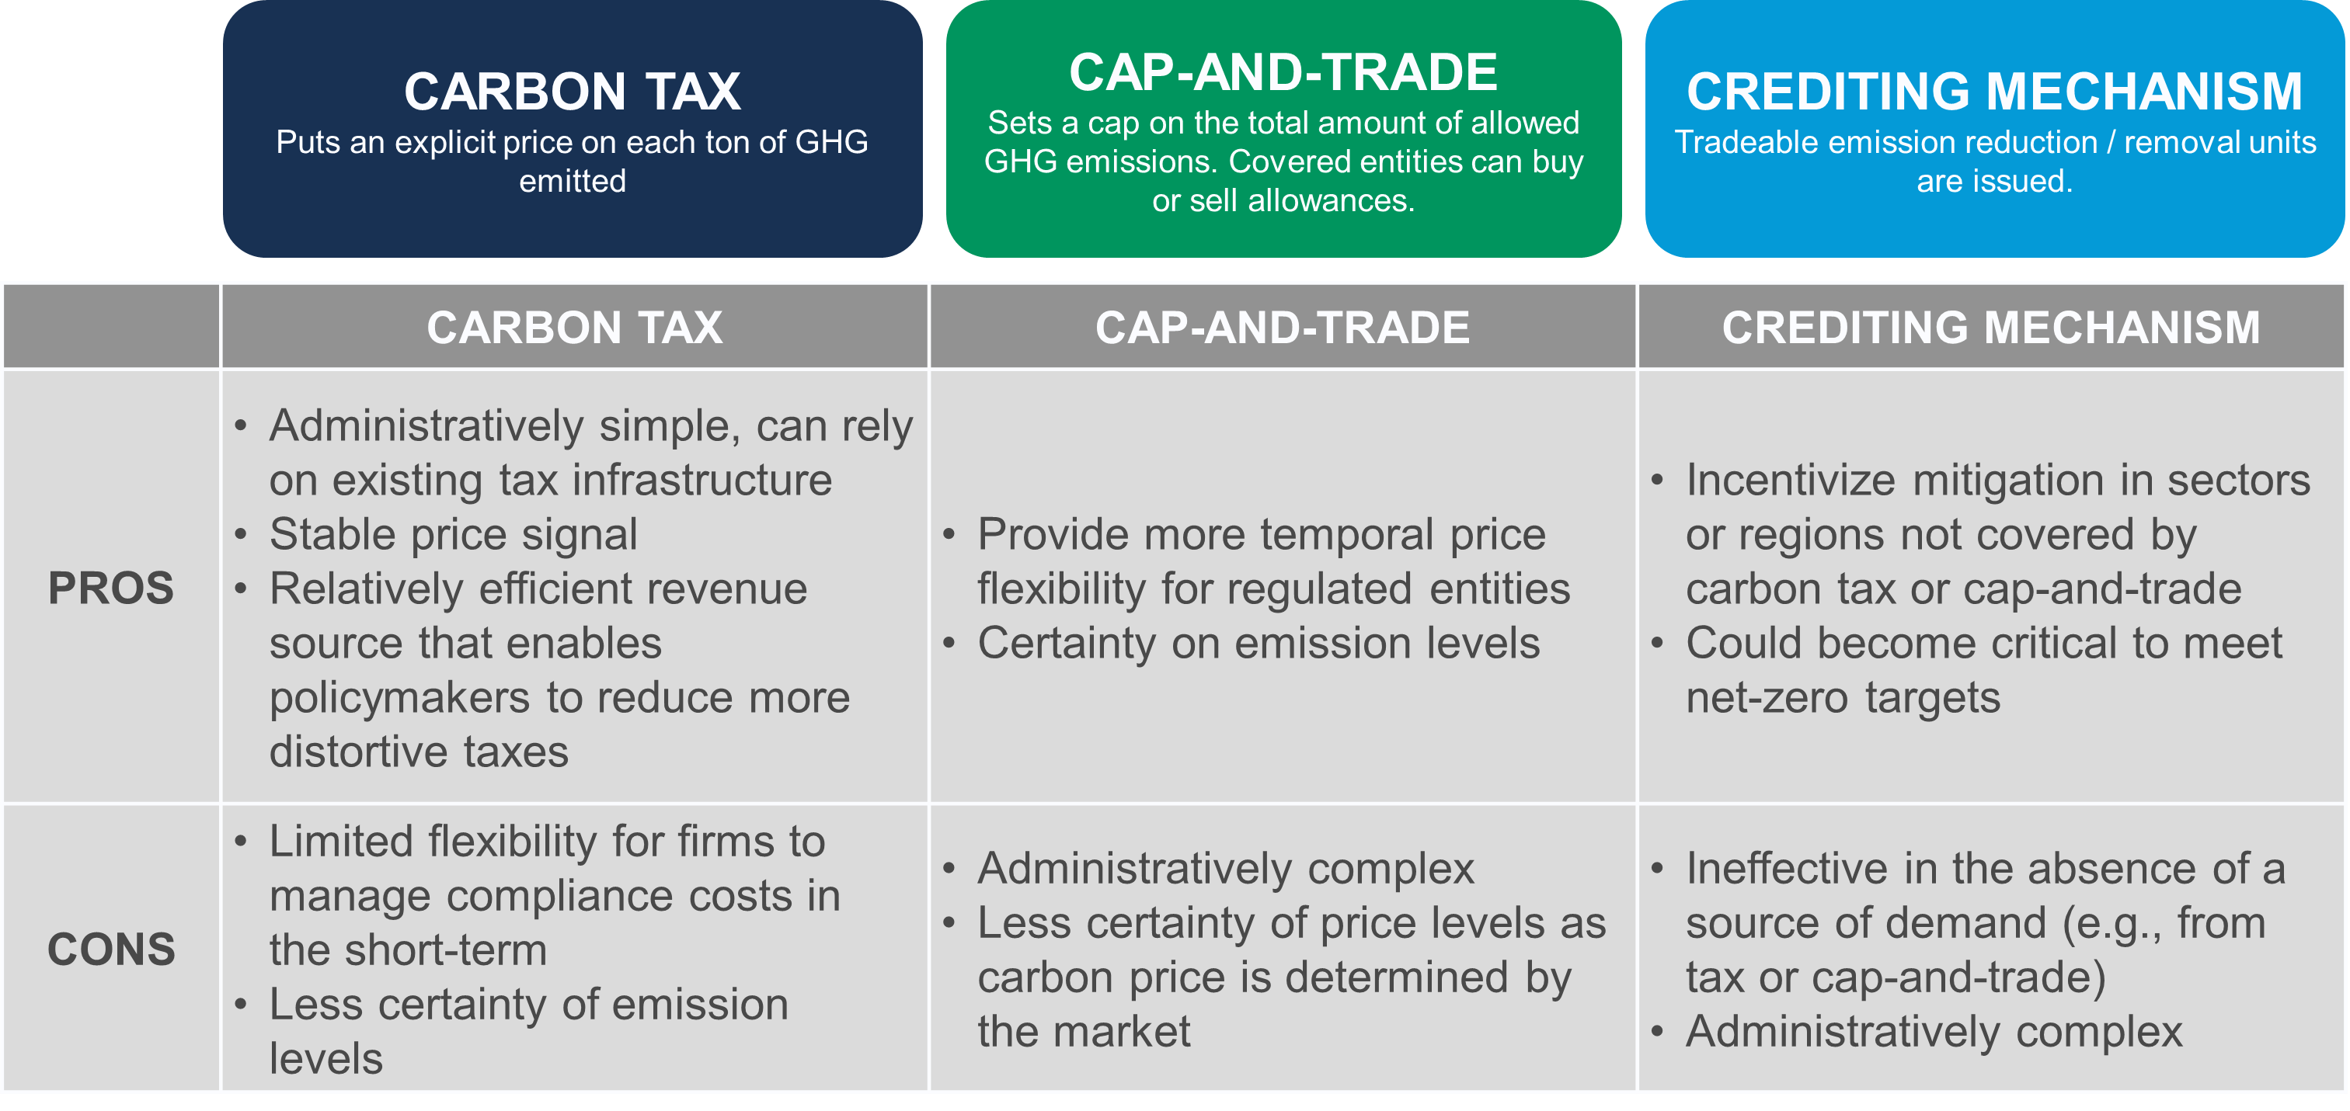

# **China’s Climate Ambition and the Pathway to “30-60 Goals”**

|  |
| --- |
|  |

China is the world’s largest carbon emitter with an annual share of 28% of global carbon emissions in 2019, despite a low per capita carbon emissions figure – 7.1 tons per person.[2] President Xi Jinping announced at UN General Assembly in 2020 that China will strive to peak CO2 emissions before 2030 and achieve carbon neutrality before 2060 setting a ground-breaking vision for the country’s climate agenda for the next four decades. China also further detailed the plans later in the same year through updated NDC submission, in which it unveiled several specific policy targets and measures in transitioning to a carbon neutral economy, including reducing its CO2 emissions intensity per unit of GDP by more than 65% from the 2005 level by 2030, increasing the share of non-fossil fuels in primary energy consumption to around 25%, and expanding the total installed capacity of wind and solar power to over 1,200 GW. Carbon peaking and neutrality targets were also included in the 14th Five-Year Plan (2021-2025) which sets the overarching national social and economic development plans.

A review of four studies on China’s transition pathways to carbon neutrality indicates that the peak of carbon emissions will occur before 2030 with a level in the range of 10-10.6 GtCO2 across all scenarios and emissions will reach near zero by 2060 (Figure 1). The following areas were identified for China to meet the “30-60 goals”: industrial restructuring, energy-saving improvements, electrification in end-use sectors, decarbonization of the power sector, consumer behaviour change, technologies innovation in bioenergy with carbon capture and storage (BECCS) and direct air capture and storage (DACS), enhancing carbon sink, building market mechanisms, and strengthened international cooperation.

1. **Pathway to China’s “30-60 Goals” in Different Scenarios**

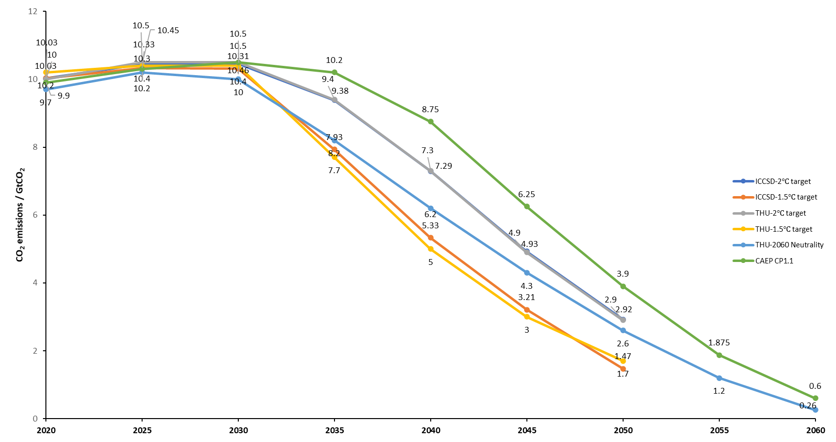

*Note*: Studies and modeling scenarios include (data source): “Research on China's long-term low-carbon development strategy and transformation pathway” by Institute of Climate Change and Sustainable Development of Tsinghua University (ICCSD-2oC target and ICCSD-1.5oC target)[3]; Towards carbon neutrality: A study on China's long-term low-carbon transition pathways and strategies” by Tsinghua University (THU-2oC target and THU-1.5oC target)[4], “Scenario analysis of low-carbon energy transition under 2060 carbon neutral target” by Xiliang Zhang (THU-2060 Neutrality)[5]; “China’s carbon emission pathway under the carbon neutrality target” by Chinese Academy of Environmental Planning (CAEP CP1.1)[6]

In the 2oC and 1.5oC Target scenario developed by He, et al (2022), electricity and industrial sector represent the greatest emission reduction potential with a 75% and a 63% reduction respectively by 2050 compared with 2020 level. Reductions of non-CO2 emissions will play a critical role for achieving carbon-neutral by 2060 because non-CO2 emissions will only drop by 30%-50% by 2050 in both scenarios leaving the last 10 years with a large non-CO2 budget (Figure 2).

1. **GHG Emissions to 2oC and 1.5oC Target by Sector**

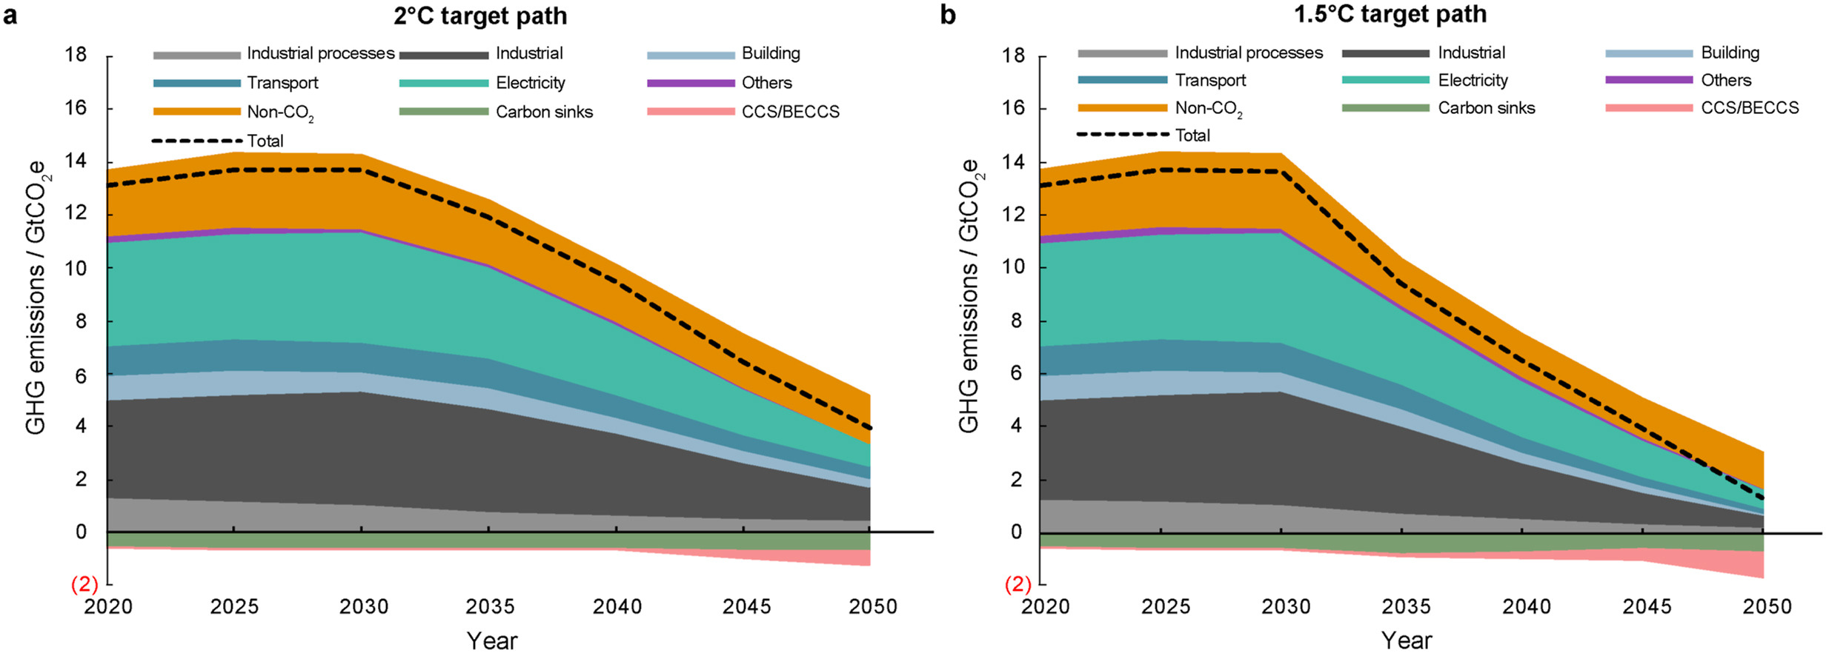

*Source*: He, et al, 2022[7]

# **The Role of ETS in Achieving Carbon Neutrality**

## **Current state of China’s ETSs**

China launched seven pilot ETSs in Beijing, Tianjin, Shanghai, Chongqing, Hubei, Guangdong and Shenzhen between 2013 to 2014 as an effort to explore a wide range of options and best practices in constructing an economy-wide emissions trading scheme, especially in the area of cap setting and allowance allocation methods, coverage of industries, participation and compliance, MRV systems, and institutional capacity and talents. After several compliance cycles, the followings are lessons learned and areas for improvements in the future design and reform for the national ETS: first, there is a lack of insufficient regulatory enforcement and cooperation between agencies when there is an overlap between different policies at the local government level. Second, there is a strong need to diversify and scale up the trading products. Spot trading has been the single and mainstream product in most pilot ETSs which would constrain market growth and participation of financial institutions. Third, the price signal is not fully effective again due to the lack of long-term and derivatives trading products such as futures and options, and lastly, low market liquidity due to low trading volume.

Drawing from the experience of the pilot ETSs, China launched a national ETS in 2017 which came into operation in 2021. It is technically an output- and rate-based carbon market or the so-called tradable performance standard (TPS) mechanism, with a flexible cap related to activity levels. Instead of an absolute cap, under the TPS the carbon emissions cap is jointly determined by emissions and economic output of participating power facilities. The TPS system is closer to the kind of direct regulation that the Chinese government are used to, and it aligns with China’s emissions intensity (ratio of emissions to GDP) strategy rather than achieving a given emissions level.

The national ETS initially covers only the power sector, which accounts for over 40% of China’s total CO2 emissions or about 4.5 billion metric tons of CO2 (tCO2) per year. 2,162 companies in the power sector participated in the first compliance period ending at the end of 2021. While the prices for emissions allowances (CEA) remain relatively low compared to other pricing systems, the price is stable in the range of 40-60 yuan/tCO2. As of December 31, 2021, a total of 179 MtCO2 of allowances were traded in 2021, representing a cumulative turnover of close to 7.7 billion yuan (USD 1.2 billion)[8].

At the subnational level, a total of 72 million allowances were traded in the eight ETS pilots in 2021, with a total turnover of CYN 10.06 billion. Guangdong ETS was the most active, with 27.13 million traded and a turnover of CNY 1.04 billion. Chongqing ranked second with 11.28 million tonnes traded at a value of CYN 294 million. Carbon markets in Hubei, Shenzhen and Tianjin had a cumulative annual trading volume of 9.64 million, 7.11 million and 6.62 million, respectively. Trading volume in Fujian and Shanghai was relatively low at 2.22 million and 2.06 million, respectively. (Figure 3)

1. **China’s ETSs Trading Volume in 2021**

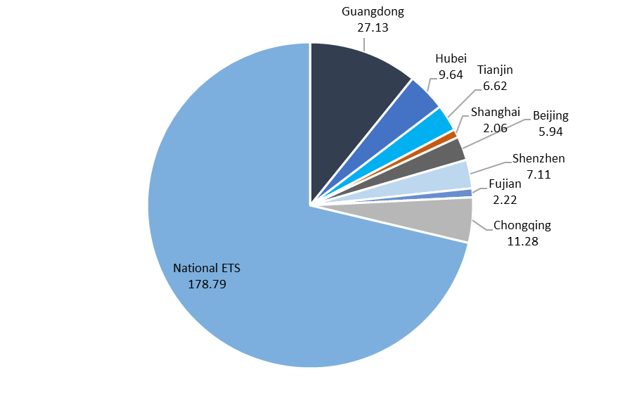

*Data source*: IETA Carbon Market Business Brief

## **Potential role of ETS in supporting carbon neutrality**

[Add intro para on how ETS theoretically can support carbon neutrality]

An ETS can play a strong role in China’s carbon neutrality policy mix. ETS is generally preferable where achieving an emissions target is a priority and/or where there are barriers to public acceptance of a carbon tax. Well-designed ETS – a cap that’s in line with national GHG emission targets on the pathway to neutrality, a broad sectoral coverage of emissions, full auctioning for the power sector, and ambitious emissions intensity benchmarks – can help raise revenues for decarbonization finance, address distributional and equity concerns, and support a sustainable and just transition to a carbon neutral economy.

In the CAEP CP1.1 model developed by the Chinese Academy of Environmental Planning (CAEP), which is the only study among the four this paper reviewed that included a baseline scenario, the cumulative carbon emissions reduction required for achieving neutrality by 2060 is estimated at 50.2 GtCO2, this is supported by a recent World Bank study that concludes that the accelerated decarbonization pathway (ADS) will lead to a

Under an accelerated decarbonization scenario that would allow emissions to peak earlier than 2030, reducing cumulative carbon emissions until 2060 by almost 55 billion tons and smoothing the impacts on GDP over time, investment needs would increase by US$3 trillion to a total of US$17 trillion.

significant reduction in cumulative emissions of almost 55 GtCO2 by 2060 to achieve China’s “30-60 goals”.[9] Taking year 2021 as an example, the annual emissions reduction from China’s carbon markets even including CCERs (which likely represent carbon abatement activates from previous years) are totaled at 0.428 billion tonnes, which is far from the neutrality-aligned 50-55 billion tonnes level in 2060 (Figure 5). This also indicates that the national ETS has a great opportunity to drive emission reductions and contribute to the achievement of China’s carbon neutrality goal in the next 35 years.

**Figure 5. Cumulative Emission Reductions Needed in 2060**

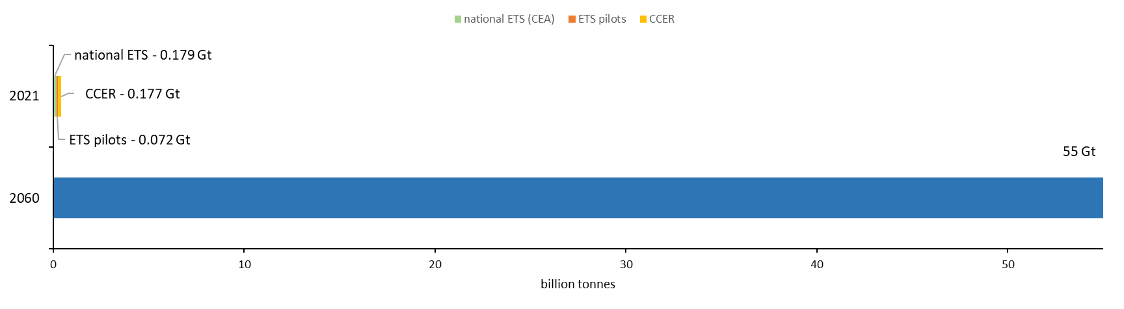

*Data source*: World Bank, IETA, ICF, SinoCarbon

In particular, China’s national ETS can have an important role in reversing the upward trend of CO2 emissions from electricity generation, supporting power sector emissions to peak well before 2030, according to an IEA study.[10] The study estimated that China’s annual CO2 emissions from electricity generation in 2035 would be 12% lower, or a drop of 570 MtCO2, under the national ETS than in the No-Carbon-Pricing Scenario. The ETS would drive emissions reductions mainly by improving the efficiency of coal-fired power generation, particularly between 2020 and 2030, and by enlarging the deployment of carbon capture, utilization and storage (CCUS) in the power sector from 2030.

55 Gt

With free allocation and multiple benchmarks in place, the impact of the national ETS on fuel-switching away from coal is nevertheless limited. Introducing auctioning in an output-based ETS could incentivize fuel switching, raise revenues to expand climate action, and lead to even greater power sector decarbonisation. In IEA’s ETS Auctioning Scenario, with the share of auctioning increasing after 2025 and gradually reaching 50% in 2035, carbon emissions from electricity generation could peak at a lower level than under free allowance allocation, reducing annual electricity generation emissions by an additional 498 MtCO2 in 2035 compared with an ETS with free allowance allocation. (Figure 6)

## **Key uncertainties**

***Future design of the ETS***

There are several potential challenges the national ETS will face and it is reported that discussions and changes are underway to improve the design of the system, such as: an absolute cap on the emissions of covered businesses, rather than a cap on carbon intensity of power production; the coverage expansion to other energy-intensive sectors; development of stronger legal enforcement through top government authorities for example the State Council; adoption of auctioning in allowance allocation; establishing price signals in the market; improvement in MRV capabilities, and adopting policy measures to ensure a “just transition”.

[Elaborate on the design issues of the ETS]

1. **Additional Emissions Reductions by National ETS Free Allocation vs Auctioning, 2025-2035**

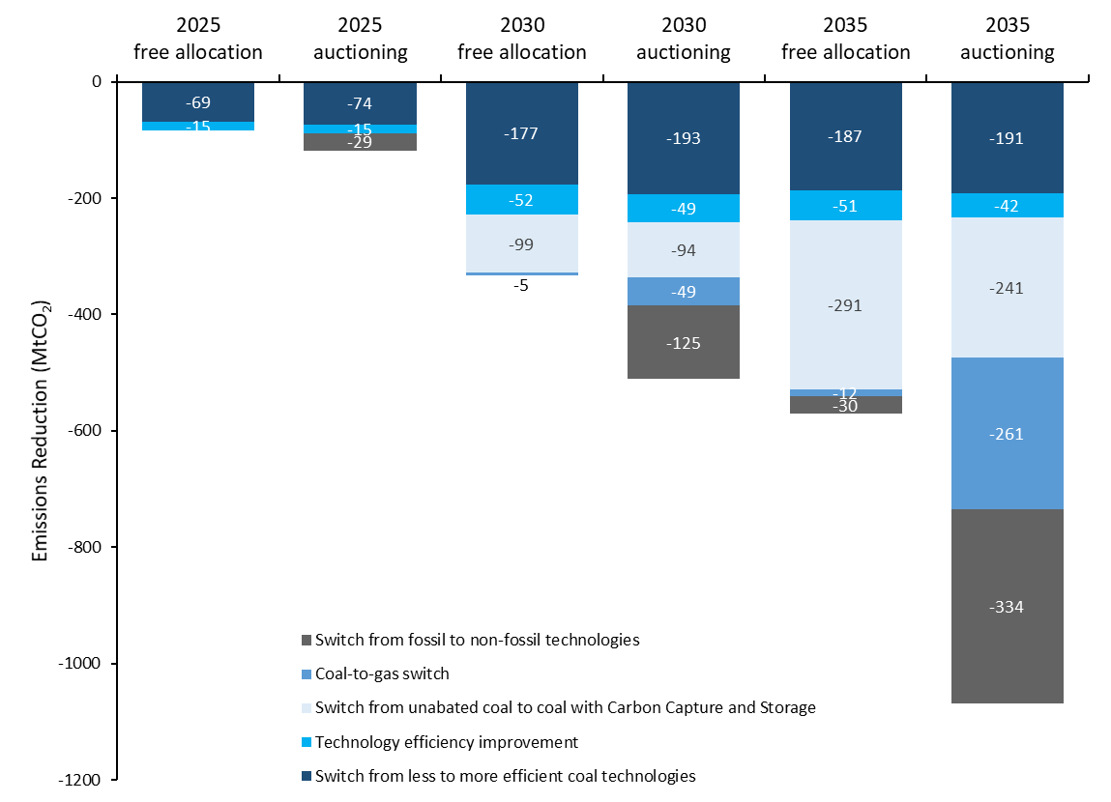

additional -34

additional -177

additional -498

*Data source*: IEA

## **Carbon price**

Both price levels and trading volume are currently very low (below USD 10/tonne) in China’s carbon markets. Carbon prices will need to rise significantly over time to drive decarbonization and affect investment decisions.

According to a study by Tianyu Qi and others (2016) [11], the carbon price should reach USD 25 by 2030 and USD 58/tCO2 by 2050 in order to limit China’s total carbon emissions below 12 GtCO2 in 2050. Weng (2018)[12] concluded that the pricing level required for China to realize its NDC commitments will need to reach USD 8/tCO2 in 2021-2025 and USD 12/tCO2 in 2026-2030. Zhang (2022) [13] used a top-down global computable general equilibrium energy-economic model – the China-in-Global Energy Model (C-GEM) to study the pathway to carbon neutrality and concluded that the price of carbon should reach USD 8-10/tCO2 in 2021-2025 and increase to USD 15/tCO2 in 2026-2030. By 2035, it should reach USD 25/tCO2 and USD 400 by 2060, which is a level that exceeds the cost of direct air carbon capture technology (DACS). This technology will only become cost-effective and unlock large scale deployment when carbon price is higher than USD 300/tCO2 in China.

## **Policy overlaps and interaction with other national mitigation strategies**

To achieve carbon neutrality, China has launched a number of policies, initiatives, and targets in mainly five categories: national carbon emission control targets, regional carbon emission control targets, energy conservation policies, renewable energy policies, and electricity marketization reform. Overlapping policies and lack of coordination between implementing agencies will hinder the development of carbon markets and weaken the impacts towards their mutual objectives. Table 2 summarizes the complex relationship between China’s emission targets at different levels and other mitigation policies. While there has been an ongoing effort of intergovernmental collaboration, it is far from enough to reach policy coherence.

1. **Policy Interaction Between China’s National ETS and Other Mitigation Policies.**

|  |  |  |  |  |
| --- | --- | --- | --- | --- |
| **Policy Instrument** | | **Targeted Scope/Entity** | **Policy Interaction** | **Coordination Outcome** |
| **National carbon emission control targets** | Regional CO2 intensity (of GDP)  targets | National level | * Unified allocation approaches and differentiated intensity targets at subnational level * Trans-regional allowance flow and assessment rules for intensity targets | * Provincial authorities allowed to use stricter allocation rules * Trans-regional allowance flow to be considered in the assessment rules |
| **Regional carbon emission control targets** | Regional and sectoral peaking | Provincial level | * Actual activity level-based free allowance allocation * Bottom-up approach to cap-setting and early peak of CO2 emissions in specific regions and sectors | * Hybrid approach for establishing the emissions cap now under consideration, i.e., a combination of bottom-up and top-down approaches * Provincial authorities allowed to use more stringent allocation rules |
| **Energy conservation policies** | Energy Saving and Low Carbon Action Plan of Top 10,000 Enterprises program | Top enterprises in 9 energy-consuming industries, such as iron and steel, non-ferrous metals, coal, electric power, petroleum and petrochemical, chemicals, building materials, textile, and pulp and paper | * Through investment in energy conservation, enterprises may cause possible double subsidies or over-subsidy * Certain enterprises can fulfil their allowance surrender obligation through the purchase of allowances under the national ETS, while trading is not considered under the energy conservation policy | * Coordinate detailed design. For example, consistency should be maintained between the approaches. For enterprises not covered by the national ETS, while bearing mandatory energy conservation responsibilities, targets should be established considering the allowance prices to ensure fair competition between different enterprises. |
| Trading of energy consumption rights | * Framework design very similar to the national ETS * Almost the same enterprises to be covered * Energy types not differentiated in the energy use rights trading system | * Repetitive regulation of enterprises not avoided from the very beginning in the policy design * Coordination of technical details of the two systems not conducted |
| Financial subsidy for energy conservation | * Achieved energy savings could be converted to emission reductions * Question as to whether generated emission reductions could be used for offsetting purposes under the ETS | * Coordination at the national level not conducted * Coordination in some provinces achieved to some extent by allowing the use of emission reductions generated to offset emissions under the pilot ETS |
| **Renewable energy policies** | Mandatory renewable energy  development targets | National and provincial level | * Eligibility of renewable energy projects to generate emission reduction credits that may be used for offsetting in the national ETS * Distributional effects of free allowance allocation in the power generation sector | * Renewable energy projects eligible to generate emission reduction credits, with additional requirements to be improved * Requirements on credits for offsetting purposes not determined * Real production-based benchmarking for free allowance allocation in the power sector |
| Renewable electricity subsidies | Renewable energy generation projects | * Renewable energy power generation subsidies may lead to lower CO2 prices | * The adjustment path of carbon emission cap target with a varying share of the renewable energy electricity target was proposed |
| Renewable Portfolio Standards | Power sector at provincial level | * The implementation of RPS weakens the demand for emission allowances, reduces power generation and profit * RPS policy induces substantial capacity increases in resource-rich areas * ETS leads to substantial capacity increases in high-demand areas. | * The government should reasonably coordinate the optimal application direction and scope of different policies, give full play to the maximum complementary effect and minimum conflict effect under the policy combination. * Necessary to establish a linkage mechanism between key planning projects and policy systems. * Integrating market is more economically efficient, as long as the corresponding targets are set in the efficient coordination interval. |

The ongoing power sector reform will also have an impact on carbon markets which is another example of overlapping policies. In 2021, China announced plans to accelerate development of a unified national power market system by 2030 in support of adapting to new requirements of the carbon peaking and carbon neutral goal. Emissions from the power sector will be regulated by the National Energy Administration (NEA), on the other hand the national ETS also controls indirect emissions from electricity and heat consumption, forming a dual control on energy related emissions.

# **The Role of ETS in Achieving Carbon Neutrality**

## **Current status of carbon crediting mechanisms**

## ***CCER***

Chinese government suspended registration and approval for new CCER projects in 2017 due to low trading levels and irregularities observed in some projects. However, emission reduction credits (ERCs) are essential for a complete carbon market to stimulate emission cuts, drive greater participation beyond the compliance market, and further mobilize private financing to climate-action projects that would not otherwise get off the ground. In addition, ERCs are more financial in nature compared with carbon allowances and can support the development and circulation of more derivative products. A more active carbon financial market, with a wider range of products, will attract more capital and positive feedback into the primary carbon emissions market.

The 1,047 registered CCER projects are expected to supply an annual reduction of 142.11 MtCO2e. Figure 7 displays the registered project number and anticipated annual reduction potential by project type. Despite the current suspension, the demand of CCER is expected to grow significantly in the coming decades. Under current rules, the national ETS allows up to 5% of compliance obligations to be offset through surrender of CCERs. In addition, CCER was adopted by Carbon Offsetting and Reduction Scheme for International Aviation (CORSIA) as one of the eligible emissions units in 2020. CCER is expected to play an important role in contributing to climate goals and emissions cost reductions at both domestic and global carbon markets.

On voluntary carbon market, the Chinese government has suspended CCER project registration since 2017. As of today, 2,856 CCER projects have been validated and 1,047 have been registered, 287 of which have had their emission reductions approved for issuance. In 2021, 176.8 million tonnes of CCERs were traded, marking a significant leap from previous year. The cumulative trading volume of CCER reached 418 million as of December 31, 2021.[14] (Figure 4)

In September 2021, the Chinese government issued a document that identified three priority areas of CCER projects: forestry, renewable energy and methane utilization. This signals the policy shift towards high-quality CCER projects and avoiding potential oversupply when the CCER market reopens in future. Nature-based removal projects are included in the priority CCER project range, also BECCS and DACS (technological-based removal projects) are identified by most studies as key technology to reach carbon neutrality.

|  |
| --- |
| **Figure 4. CCER Trading Volume 2014-2021** |
|  |
| *Data source*: ICF, SinoCarbon |

1. **Number of Registered CCER Projects and Anticipated Annual Emission Reductions (MtCO2e)**

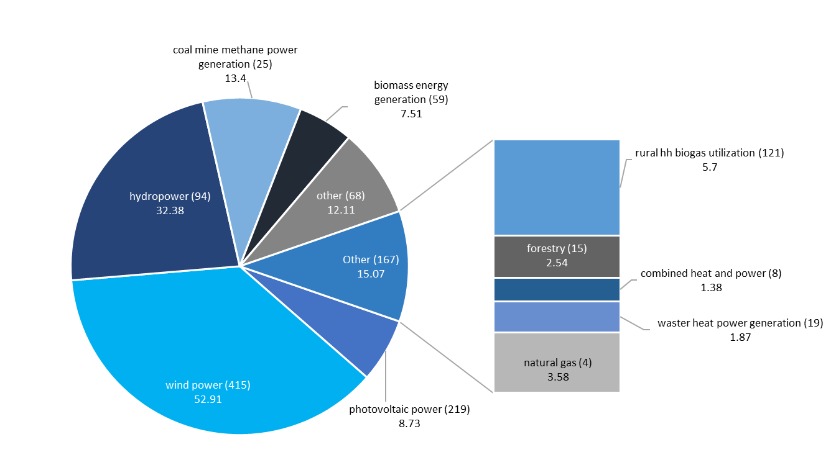

*Data source*: EDF, SinoCarbon

## 

## ***China’s engagement in global voluntary carbon markets***

As of today, there are 285 registered projects under Gold Standard with a total issuance of 32 MtCO2e, and 444 registered projects under Verified Carbon Standard (VCS) with a total issuance of over 83 MtCO2e. (Figure 8)

[Add further details on VCM projects – e.g., what is the price? What are the main project categories?]

1. **Number of Registered Chinese Projects (inner circle) and Annual Emission Reductions (MtCO2e) at GS and VCS**

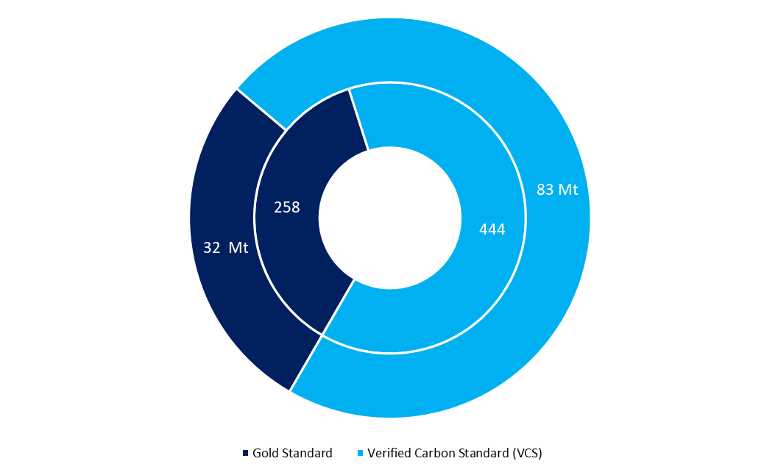

*Data source*: GSF Registry, Verra Registry

## **Carbon removals are necessary to achieve net zero**

[Add intro paras on theoretically how can carbon credits can support carbon neutrality, i.e., buy providing an additional source of revenue and a “carrot”. The IETA study could be useful in this context. Can also include language from the CPLC paper]

A recent study[15] suggests that post-2020 carbon markets have the potential to reduce the total cost of implementing countries’ climate pledges, known as nationally determined contributions (NDCs), by more than half (~$250 billion/year in 2030). While the challenges of realizing the full cost-savings potential and enhanced climate ambition should not be underestimated, these market mechanisms could play an important role in reaching net-zero goals. Additional research is required to ensure that carbon markets are designed to effectively contribute to countries’ long-term climate goals to achieve net zero emissions by 2050.

In the 2oC and 1.5oC target transition pathway scenarios developed by He, et al (2022) (Figure 2), the annual carbon removals from carbon sink (agriculture, forestry and land use) should reach 700-780 MtCO2e and removals through CCS and BECCS should reach 510-880 MtCO2e per year by 2050 in order to achieve China’s 30-60 goals and the Paris Agreement targets. For comparison, the anticipated annual CO2 carbon removals from all registered CCER projects (1,047) are 2.54 MtCO2e for nature-based and currently 0 registered for technological-based removal credits. (Table 1)

1. **Carbon Removals Needed in 2050 (MtCO2e)**

|  |  |  |  |
| --- | --- | --- | --- |
|  | 2021 (anticipated from registered CCER projects) | 2050 – 2oC target | 2050 – 1.5oC target |
| **Nature-based** | 2.54 | 700 | 780 |
| **Technological-based** | 0 | 510 | 880 |

*Data source*: EDF, SinoCarbon, He, et al (2022)

## **Key uncertainties**

***CCER scheme and regulation***

It remains unclear when CCER approvals will restart, however China is expected to resume the China GHG Voluntary Emission Reduction Program and the market for CCER soon. There were around 40 million tonnes of CCERs circulating in the market when approvals were halted in 2017, 33 million tonnes have been used under the 5% offset rules during the first implementation period of the national ETS. Now the stock of historical CCERs has been significantly consumed, and the Beijing Green Exchange was tasked by the government in 2021 to develop a national trading platform for CCERs, these all point to the speculation of the possible relaunch of the CCER program.

The other challenge for the CCER is to meet the requirements of CORSIA’s eligible emission units. The Technical Advisory Body (TAB) of ICAO pointed out through their assessment that current CCER scheme does not have sufficient requirements to ensure the additionality of CCER projects, and needs to ensure that the eligible emission units do not arise from any legal and regulatory mandates; improvements are required to address double counting; it is not suggested to impose additional restrictions on CCER project scope beyond those that are explicitly excluded in the application documents and assessment reports.

***Uncertainties about accounting rules (corresponding adjustment and double counting)*** [Rachel to add]

# **Recommendations for Future Development of China’s Carbon Markets**

1. **Policy Priorities to Strengthen China’s Carbon Markets**

**Add concluding points:**

* **ETS can send a price signal and support decarbonization]**
* **Carbon crediting mechanisms can mobilize additional resources, particularly for removal projects**
* **However, ETS and CCERs have not supported abatement to the level required by carbon neutrality**
* **Moving forward, there are various short, medium and long-term policy priorities**

**For the table, suggest adding a point about developing a strategy on how ETS and carbon crediting mechanism can support net zero**

|  |  |
| --- | --- |
| **Rationale** | **Policy Options** |
| **1. Improve the design to have a fully functioning national ETS** | |
| A fully developed and effective carbon market will play a stronger role in incentivizing cost-effective emission reductions and accelerate and contribute to the achievement of China’s “30-60 goals”. | * Transition to an absolute emission cap to ensure long-term emissions trajectory certainty. * Tighten predetermined emissions intensity benchmarks for each fuel and technology and gradually merge them to enhance the effectiveness of the output-based ETS design and cost-effectively transform the power sector. * Expand to other energy-intensive sectors. * Establish price signals in the market by providing additional and varied trading products and other derivatives to also facilitate liquidity. * Introduce auctioning in allowance allocation in incentivize fuel switching and generating revenues to expand climate action. * Strengthen the rules and penalties around monitoring, reporting and verification (MRV) of emissions. * Develop stronger legal enforcement through top government authorities, e.g. the State Council. * Finalize climate and carbon market legislation. * Conduct research and finalize the transition plan to incorporate subnational pilot ETSs into the national ETS. * Ensure a just transition. |
| **2. Develop a national offset market** | |
| Voluntary carbon markets are essential for a complete carbon market to stimulate emission cuts, drive greater participation beyond the compliance market, and further mobilize private financing to climate-action projects that would not otherwise get off the ground. In addition, credits are more financial in nature compared with carbon allowances and can support the development and circulation of more derivative products. A more active carbon financial market, with a wider range of products, will attract more capital and positive feedback into the primary carbon emissions market. | * Finalize the management rules on the trading of voluntary emission reduction of greenhouse gases and resume the China GHG Voluntary Emission Reduction Program. * Revise and improve CCER scheme design and regulations, including   1. Improve and finalize methodologies on baseline, additionality, and emission reduction accounting.   2. Simplify and standardize the implementation system of CCER to reduce regulatory and operational costs.   3. introduce additional financial derivatives, diversify trading categories, methods, and players so as to guide market expectations and form reasonable carbon pricing, 2) meet the requirements of CORSIA’s eligible emission units. * Build integrity and transparency in CCER markets and establishing robust accounting rules to ensure the avoidance of double counting. * Implement dynamic adjustments to emissions factors and offset percentage of CCER in ETS to avoid oversupply or supply shortage and to stabilize carbon prices. * Define high quality standards for removal credits. |
| **3. Strengthen policy coordination to ensure coherence with other national mitigation strategies** | |
| It is important that there is coherence with other relevant market-based mitigation policies, such as trading of energy consumption rights, and green power certificate voluntary trading system. To optimize the intended role of carbon pricing in cost-effectively driving down emissions, it is crucial that other policies do not negate its effect but are coordinated to be complementary. | * Accelerate power market reform and coordinate with the development of national ETS to amplify the effects on shared policy goals. * Strengthen policy coordination for ETS implementation in the power sector and its expansion to other industrial sectors, e.g. coordinate with renewables deployment, energy efficiency and CCUS support policies. * Ensure avoidance of double counting and double claiming between different mechanisms. * Strengthen coordination between national and subnational ETSs and coordination between different policy targets (CO2 intensity, GDP, sectoral pathways) at the provincial level. |
| **4. Strengthen research on potential linkage to global carbon markets** | |
| The EU Carbon Border Adjustment Mechanism (CBAM) will have a significant effect on both international trade and climate diplomacy in China. It is important to understand the impacts and improve China’s ETS design accordingly (intensity-based cap vs absolute cap, sector coverage extension, etc.) | * Conduct research studies on potential impact of CBAM on China’s carbon markets and on international competitiveness. * Develop carbon assessment toolkits of the affected products. * Conduct further research on participation in future international carbon markets and use of Article 6 credits in addition to domestic offsets. |

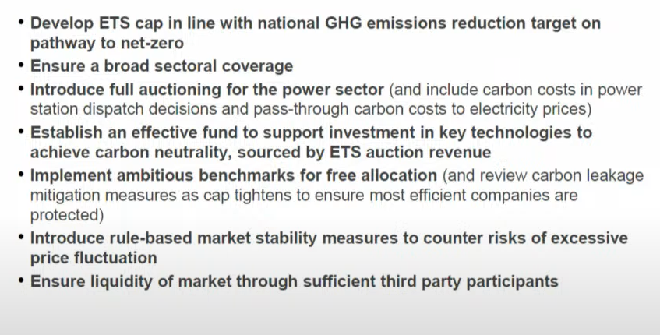

1. IPCC, 2018, Summary for Policymakers, “Special Report: Global Warming of 1.5°C”, <https://www.ipcc.ch/sr15/chapter/spm/>
2. MP Group, 2021, “Current State and Challenges of Global Carbon Emissions”, <https://m.thepaper.cn/baijiahao_14544988>
3. Institute of Climate Change and Sustainable Development (ICCSD) of Tsinghua University, 2020, “Comprehensive report on China's long-term low-carbon development strategies and pathways”, Chinese Journal of Population, Resources and Environment, 18 (4): 263-295, [https://cssd1992.org/files/Yzgzgtb82RMjAQml9xvs.pdf](https://cssd1992.org/files/Yzgzgtb82RMjAQml9xvs_%E3%80%8A%E4%B8%AD%E5%9B%BD%E9%95%BF%E6%9C%9F%E4%BD%8E%E7%A2%B3%E5%8F%91%E5%B1%95%E6%88%98%E7%95%A5%E4%B8%8E%E8%BD%AC%E5%9E%8B%E8%B7%AF%E5%BE%84%E7%A0%94%E7%A9%B6%E3%80%8B%E7%BB%BC%E5%90%88%E6%8A%A5%E5%91%8A.pdf)
4. He, et al, 2022, “Towards carbon neutrality: A study on China's long-term low-carbon transition pathways and strategies”, Environmental Science and Ecotechnology Volume 9, January 2022, 4, <https://doi.org/10.1016/j.ese.2021.100134>
5. ZHANG Xiliang, 2020, “Scenario analysis of low-carbon energy transition under carbon neutral goal by 2060”, <https://www.sxfxer.com/info/news.php?id=864>
6. CAI Bofeng, CAO Libin, LEI Yu, et al, 2021, “China’s carbon emission pathway under the carbon neutrality target[J]”, China population, resources and environment, 31(1):7-14.
7. He, et al, 2022, “Towards carbon neutrality: A study on China's long-term low-carbon transition pathways and strategies”, Environmental Science and Ecotechnology Volume 9, January 2022, 4, <https://doi.org/10.1016/j.ese.2021.100134>
8. Ministry of Ecology and Environment, <https://www.mee.gov.cn/ywgz/ydqhbh/wsqtkz/202112/t20211231_965906.shtml>
9. World Bank, 2022, “China Country Climate and Development Report”, <https://www.worldbank.org/en/country/china/publication/china-country-climate-and-development-report>
10. IEA, 2021, “The Role of China’s ETS in Power Sector Decarbonisation”, <https://www.iea.org/reports/the-role-of-chinas-ets-in-power-sector-decarbonisation>
11. Qi，T. Y.，Winchester，N.，Karplus，V.，Zhang，D. and Zhang，X. L, 2016, “An Analysis of China’s Climate Policy Using the China in-Global Energy Model”，Economic Modelling，Vol. 52，650~660, <https://doi.org/10.1016/j.econmod.2015.09.036>
12. Weng，Y. Y.，Zhang，D.，Lu，L. L. and Zhang，X. L.，2018, “A General Equilibrium Analysis of Floor Prices for China’S National Carbon Emissions Trading System” ，Climate Policy, 18: 60~70, <https://doi.org/10.1080/14693062.2018.1464895>
13. Zhang Xiliang, Huang Xiaodan, et al, 2022, “Research on the Pathway and Policies for China's Energy and Economy Transformation toward Carbon Neutrality”, Management World, 1:35-52
14. ICF, SinoCarbon, 2022, “2021 China Carbon Pricing Survey”, <http://www.chinacarbon.info/wp-content/uploads/2022/02/EN_2021-China-Carbon-Pricing-Survey-Report.pdf>
15. IETA, CPLC, and University of Maryland, 2019, “The Economic Potential of Article 6 of the Paris Agreement and Implementation Challenges”, [https://static1.squarespace.com/static/..../CLPC_IETA_A6+report](https://static1.squarespace.com/static/54ff9c5ce4b0a53decccfb4c/t/5d89fee3ad16452612f73374/1569333620247/CLPC_IETA_A6+report)